Leetcode Problem 1. (Easy)

Remove Duplicates from Sorted List

Given the head of a sorted linked list, *delete all duplicates such that each element appears only once*. Return *the linked list****sorted****as well*.

**Example 1:**

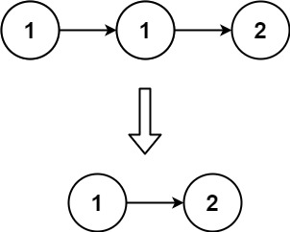

**Input:** head = [1,1,2]

**Output:** [1,2]

**Example 2:**

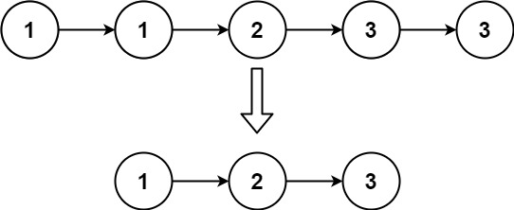

**Input:** head = [1,1,2,3,3]

**Output:** [1,2,3]

**Constraints:**

* The number of nodes in the list is in the range [0, 300].
* -100 <= Node.val <= 100
* The list is guaranteed to be **sorted** in ascending order.

Link: <https://leetcode.com/problems/remove-duplicates-from-sorted-list/>

class Solution {

public ListNode deleteDuplicates(ListNode head) {

if (head == null || head.next == null) {

return head;

}

ListNode current = head;

while (current != null && current.next != null) {

if (current.val == current.next.val) {

current.next = current.next.next;

} else {

current = current.next;

}

}

return head;

}

}

